ubuntu 安装oracle jdk方法如下：

打开终端窗口后执行如下命令：

sudo add-apt-repository ppa:webupd8team/java

sudo apt-get update

sudo apt-get install oracle-java8-installer

sudo apt-get install oracle-java8-set-default

如果安装java9就把上面的“java8”改成"java9"。8和9可以同时安装，执行“sudo apt-get install oracle-java8-set-default”后java8设定为缺省版本，执行“sudo apt-get install oracle-java9-set-default”后java9设定为缺省版本。

ubuntu安装钉钉方法如下：

在浏览器中打开 <https://github.com/nashaofu/dingtalk/releases>

下载 <https://github.com/nashaofu/dingtalk/releases/download/v1.4.2/dingtalk_1.4.2_amd64.deb> 进行安装

初次进入系统后要在终端窗口执行下列命令：

sudo apt update

sudo apt upgrade

其他工具安装：

sudo apt install git git-flow

wget <https://dl.google.com/linux/direct/google-chrome-stable_current_amd64.deb>

sudo apt install ./google-chrome-stable_current_amd64.deb

nodejs安装：

sudo apt install curl

浏览器打开 [https://nodejs.org/en/download/package-manager/](https://nodejs.org/en/download/package-manager/" \l "debian-and-ubuntu-based-linux-distributions)

点击 Debian and Ubuntu based Linux distributions 后按照页面提示在终端窗口处理

curl -sL https://deb.nodesource.com/setup_8.x | sudo -E bash -

sudo apt-get install -y nodejs

各工具路径统一如下：

sts /usr/local/sts-bundle

wps office安装：

在浏览器打开 <http://wps-community.org/download.html>

下载 wps-office_1*_i386.deb

http://kdl1.cache.wps.com/ksodl/download/linux/a21//wps-office_10.1.0.5707~a21_i386.deb

或者

在浏览器打开 <http://www.ubuntukylin.com/application/show.php?lang=cn&id=278>

下载 64位安装包

http://archive.ubuntukylin.com:10006/ubuntukylin/pool/main/w/wps-office/wps-office_10.1.0.6115_amd64.deb

在浏览器打开 [http://wps-community.org/download.html?vl=fonts#download](http://wps-community.org/download.html?vl=fonts" \l "download)

下载 wps-office-fonts_1.0_all.deb

http://kdl.cc.ksosoft.com/wps-community/download/fonts/wps-office-fonts_1.0_all.deb

安装上述软件包

浏览器打开 <https://github.com/IamDH4/ttf-wps-fonts>

按照页面的操作安装其他字体

teamviewer安装：

浏览器打开 <https://www.teamviewer.com/en/download/linux/>

下载ubuntu 64位版 <https://download.teamviewer.com/download/linux/teamviewer_amd64.deb>

安装软件包

filezilla安装：

添加getdeb源

sudo sh -c 'echo "deb http://archive.getdeb.net/ubuntu xenial-getdeb apps" >> /etc/apt/sources.list.d/getdeb.list'

添加key

wget -q -O - http://archive.getdeb.net/getdeb-archive.key | sudo apt-key add -

安装filezilla

sudo apt update

sudo apt install filezilla

或者

官网下载linux执行包，再安装补充运行库

sudo apt install libpng16-16

sudo add-apt-repository ppa:ubuntu-toolchain-r/test

sudo apt-get update

sudo apt-get install gcc-4.9

sudo apt-get upgrade libstdc++6

strings /usr/lib/x86_64-linux-gnu/libstdc++.so.6 | grep GLIBCXX

vscode安装：

浏览器打开页面 <https://code.visualstudio.com/docs/setup/linux> 操作如下

curl https://packages.microsoft.com/keys/microsoft.asc | gpg --dearmor > microsoft.gpg

sudo mv microsoft.gpg /etc/apt/trusted.gpg.d/microsoft.gpg

sudo sh -c 'echo "deb [arch=amd64] https://packages.microsoft.com/repos/vscode stable main" > /etc/apt/sources.list.d/vscode.list'

sudo apt-get update

sudo apt-get install code # or code-insiders

git参数设置：

git config --global http.sslVerify "false" #设置禁用ssl证书验证

git config --global user.name "YOUR NAME" #使用者的姓名

git config --global user.email YOUR EMAIL #使用者的邮箱

git config credential.helper store #在git仓库目录下设定自动保存登录的用户名和密码

或

git config --global credential.helper store #在系统全局设定自动保存登录的用户名和密码

安装Linux版钉钉

$ wget <http://172.18.3.180/SOFT1/down/dtalk.deb>

$ sudo dpkg -i dtalk.deb

$ sudo apt install -f

安装Linux版的微信

$ sudo apt install nodejs npm -y

$ sudo ln -s /usr/bin/nodejs /usr/bin/node

$ git clone https://github.com/geeeeeeeeek/electronic-wechat.git# Go into the repositorycd

$ npm install && npm start

# 在启动栏找到微信，鼠标右键，锁定到启动栏

安装google-chrome

$ wget <http://172.18.3.180/SOFT1/down/google-chrome-stable_current_amd64.deb>

$ sudo dpkg -i google-chrome-stable_current_amd64.deb

$ sudo apt instal -f

其它软件DEB包请在172.18.3.180/SOFT1上查看，如需要安装上面的deb包，步骤如下

$ sudo dpkg -i xxx.deb

$ sudo apt install -f

安装sts（需要先安装jdk)

$ wget <http://172.18.3.180/SOFT1/down/spring-tool-suite-3.9.1.RELEASE-e4.7.1a-linux-gtk-x86_64.tar.gz>

$ tar xf spring-tool-suite-3.9.1.RELEASE-e4.7.1a-linux-gtk-x86_64.tar.gz

$ sudo mv sts-bundle /usr/local/

$ cd /usr/local/sts-bundle/sts-3.9.1.RELEASE

$ ./STS

在启动栏找到STS，右键，锁定到启动栏

解压rar的方法：

浏览器打开 http://www.peazip.org/peazip-linux.html

下载GTK2 deb包 https://osdn.net/dl/peazip/peazip_6.5.0.LINUX.GTK2-2_i386.deb

安装deb包

配置剪切版

$ wget <http://packages.linuxdeepin.com/deepin/pool/main/d/deepin-scrot/deepin-scrot_2.0-0deepin_all.deb>

$ sudo dpkg -i deepin-scrot_2.0-0deepin_all.deb

$ sudo install -f

$ sudo apt install python-gtk2

设置快捷键

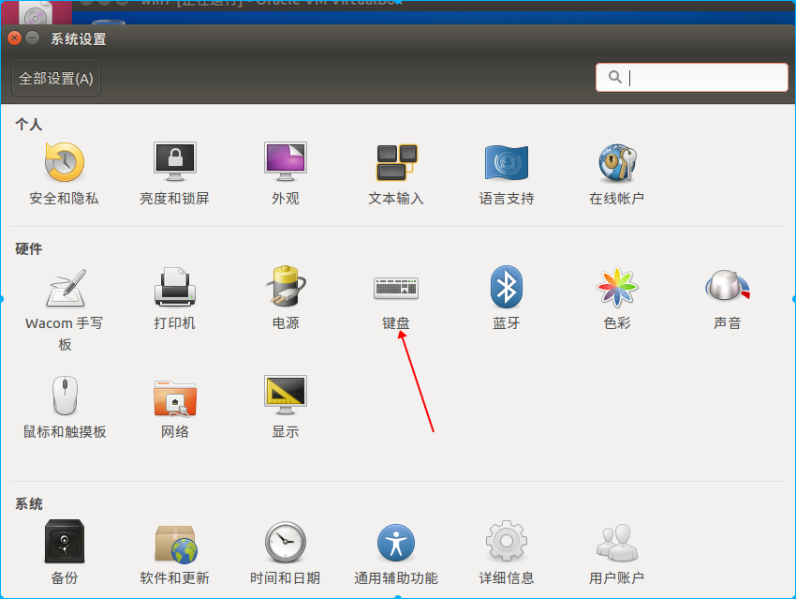

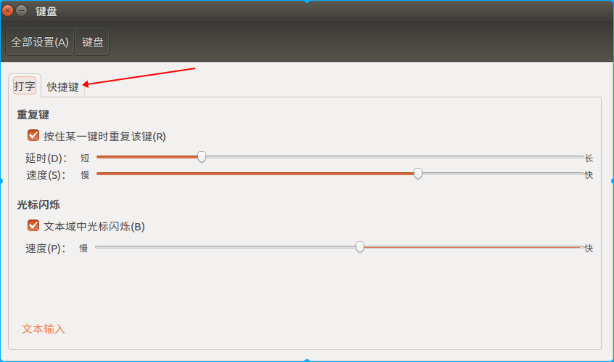

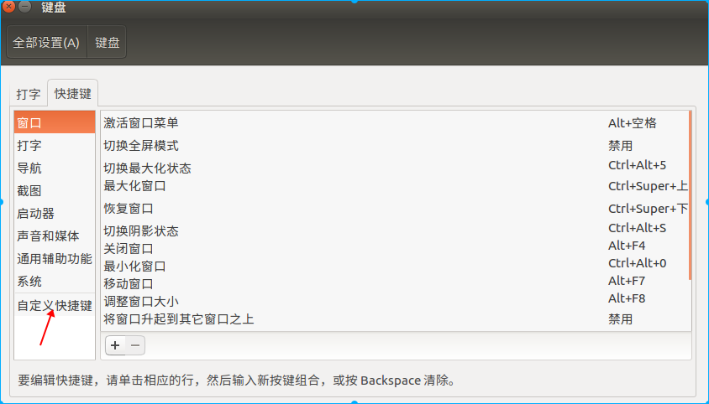

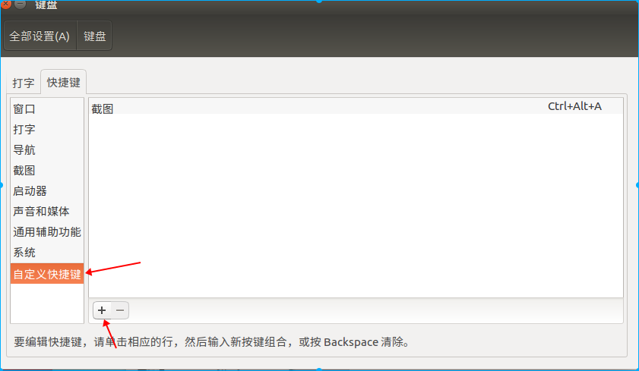

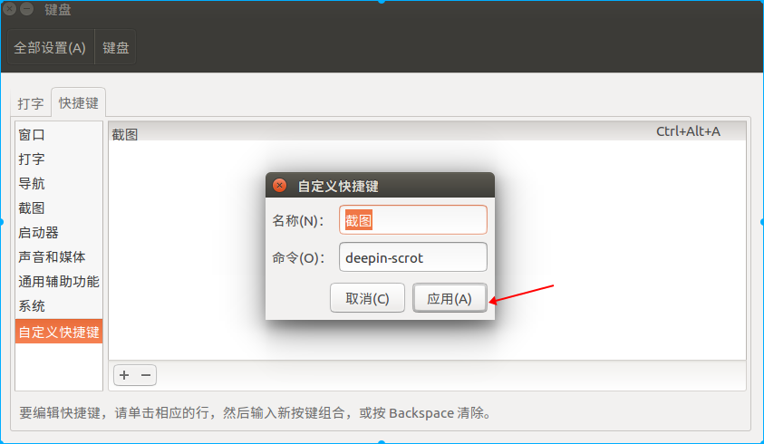

单击设的快捷键，设置自己的快捷键，比如: Ctrl+Alt+A,默认会截图到剪切板

打印机设置

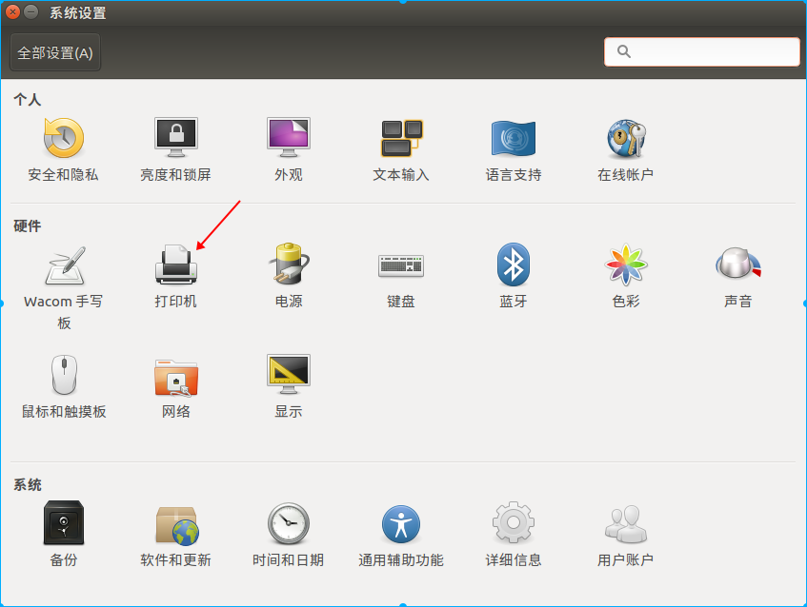

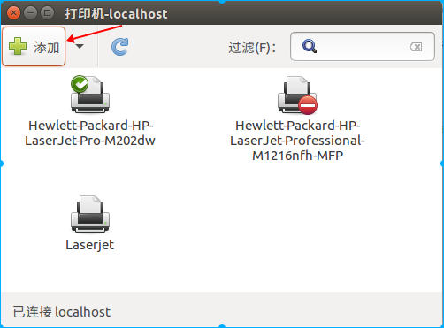

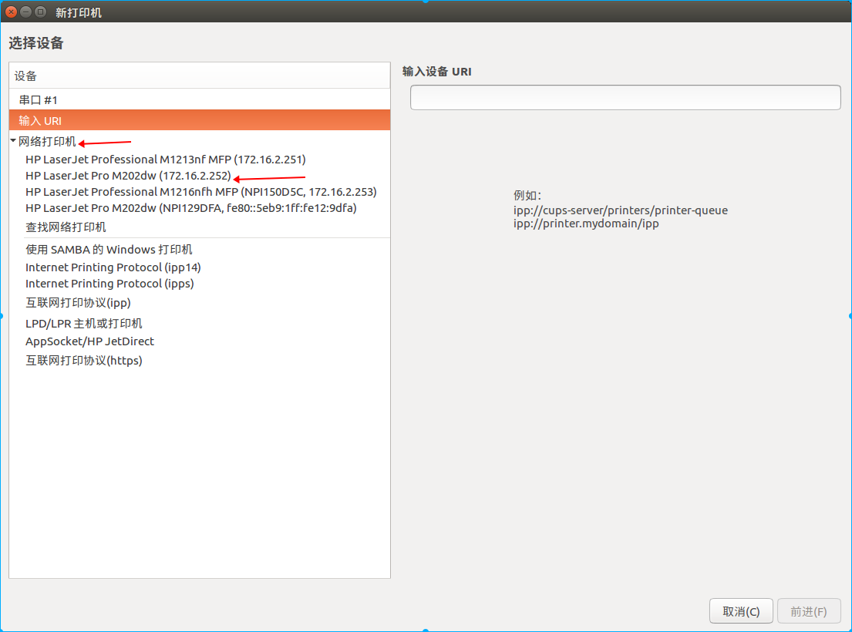

点网络打印机后，需要等软件查找打印机

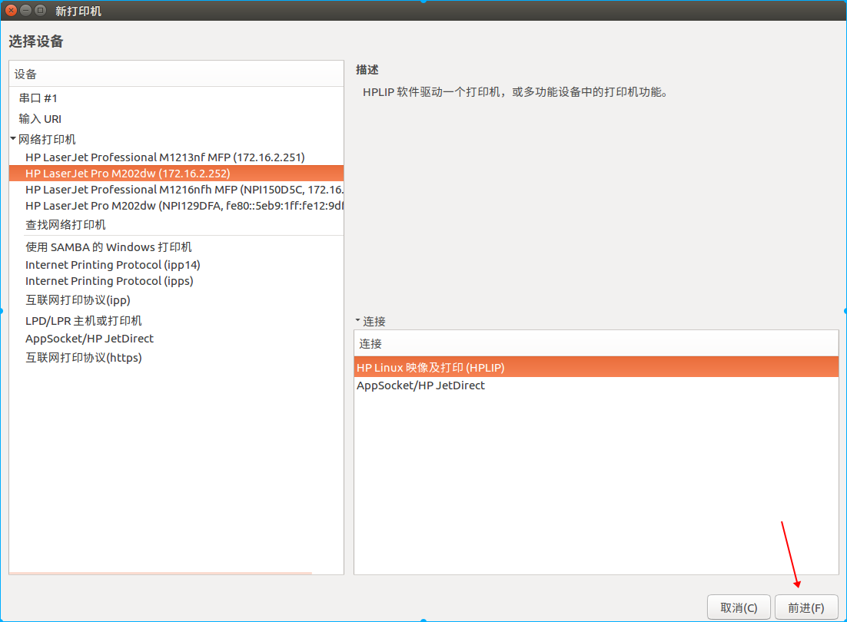

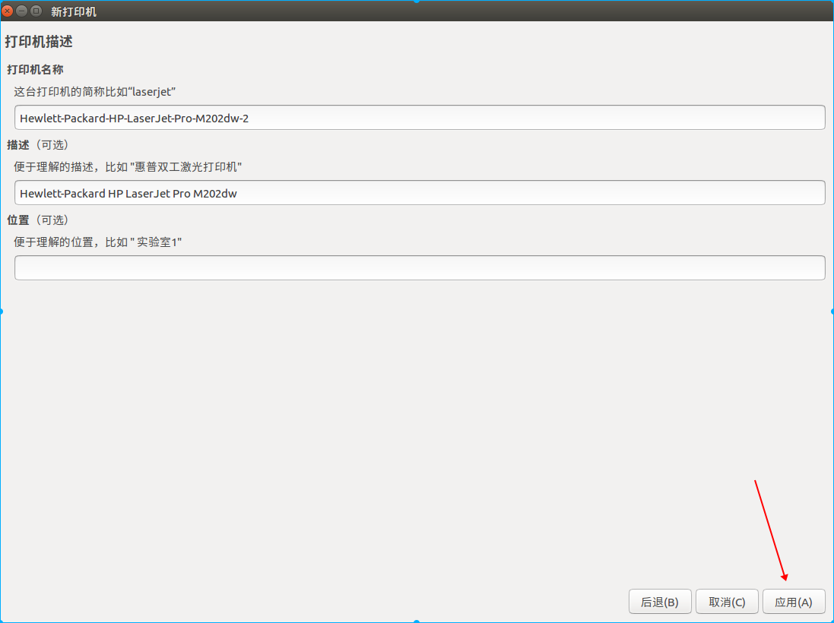

联想FN 键，解决方案

1、cd “自己的git文档目录”

2、git clone https://github.com/lentinj/tp-compact-keyboard.git

3、cd tp-compact-keyboard/tp-compact-usb-keyboard && make

4、sudo cp ./tp-compact-usb-keyboard /usr/local/bin &&

sudo chmod +x /usr/local/bin/tp-compact-usb-keyboard

5、sudo vim /etc/rc.local

在exit 0上方加入一行

/usr/local/bin/tp-compact-usb-keyboard /dev/hidraw1

1. 重启

MariaDb

https://downloads.mariadb.org/mariadb/repositories/#mirror=tuna

Here are the commands to run to install MariaDB on your Ubuntu system:

sudo apt-get install software-properties-commonsudo apt-key adv --recv-keys --keyserver hkp://keyserver.ubuntu.com:80 0xF1656F24C74CD1D8

sudo add-apt-repository 'deb [arch=amd64,i386,ppc64el] <http://mirrors.tuna.tsinghua.edu.cn/mariadb/repo/10.2/ubuntu> xenial main'

Once the key is imported and the repository added you can install MariaDB with:

sudo apt update

sudo apt install mariadb-server

See [Installing MariaDB .deb Files](http://mariadb.com/kb/en/installing-mariadb-deb-files/) for more information and for instructions on installing MariaDB Galera Cluster.

You can also create a custom MariaDB sources.list file. To do so, after importing the signing key as outlined above, copy and paste the following into a file under */etc/apt/sources.list.d*/(we suggest naming the file MariaDB.list or something similar), or add it to the bottom of your */etc/apt/sources.list* file.

# MariaDB 10.2 repository list - created 2018-03-05 00:39 UTC# <http://downloads.mariadb.org/mariadb/repositories/>

deb [arch=amd64,i386] <http://mirrors.tuna.tsinghua.edu.cn/mariadb/repo/10.2/ubuntu> xenial main

deb-src <http://mirrors.tuna.tsinghua.edu.cn/mariadb/repo/10.2/ubuntu> xenial main

 had this issue as well.

The problem seems to stem from the ssl module not being enabled when building Python 3.6.0.

I got around this by uncommenting lines 209-212 in Python-3.6.0/Modules/Setup

SSL=/usr/local/ssl

_ssl _ssl.c \

-DUSE_SSL -I$(SSL)/include -I$(SSL)/include/openssl \

-L$(SSL)/lib -lssl -lcrypto

and make sure libssl-dev is installed (this is the package for debian, anyway).

Once that's done, do ./configure, make, and make install again and it should work.